
TAMUCC Upward Bound Summer Academy Student Handbook 2024

Summer Welcome
Welcome to the Upward Bound Summer Academy! We are very excited about your participation in the coming weeks. The Summer Academy is designed to help our students grow as scholars and individuals, and we expect only the best from you. Please take the time to read through this handbook so that you are fully aware of what is expected from you this summer. We expect you to follow our rules, attend class, participate fully in activities, be a role model, study hard, and grow from the UB experience. We see the potential you have, so please be willing to accept our help and guidance and use them to help make your summer better and more productive.

Why Should You Participate in the Summer Academy?

- Because it will prepare you for your classes next year – you will be ahead of all your classmates!

- Because you will get to know new people in the program! New students are accepted every year. There are new students to meet every year! While some experiences are similar each summer, we do things that keep it different each year!

Summer Academy Components

Weeks 1-6 – Academic Experience TAMUCC
Students attend classes scheduled as college classes to experience a college time schedule. Classes offered are designed for students to get a jump-start for the upcoming school year in Math, Science, English, and Foreign Language. Students also take classes that improve their personal skills for their future in Upward Bound.
Week 7 – College(s) Tour
The last week of the Summer Academy is the college tour. On the college tour, students get to travel to a destination somewhere in the United States to visit colleges, attend cultural events and places, and have experiences in places that are not usually available to them in Corpus Christi. We visit at least 3 colleges on this trip.

Goals
Our goals and purposes for the Summer Academy include:
- Enhancing students' academic skills and abilities
- Helping students feel comfortable in a college environment
- Would give the participants a college going experience
- Creating a sense of trust and kinship with fellow UB students and staff

Academic Component (Week 1-6)

SCHEDULES
Students are placed in classes according to what classes they are taking next year and what classes they have already taken.

TAMUCC Map
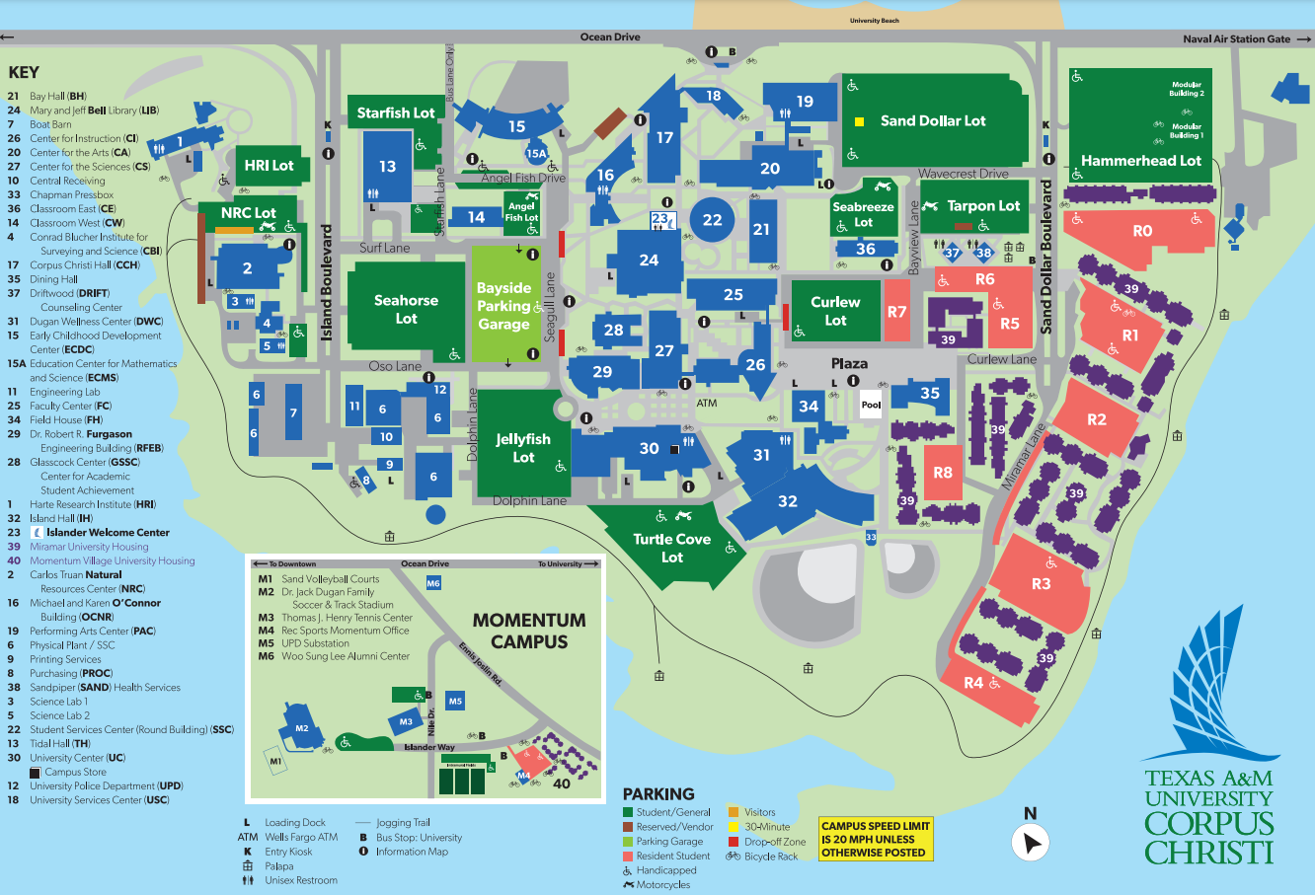

Respect Policy
You are expected to use mature judgment in all your encounters with peers and adults whether you are
at an official UB activity or not. In other words, in the dining hall, walking to class with friends, you are to act in a mature and respectful way to EVERYONE! Just because a UB staff member is not present does not mean you can disregard rules. You must treat others as you want to be treated. Think before you speak. Put yourself in the other person’s shoes and consider what you are saying. Students will refrain from gossiping and spreading rumors regarding any members of UB staff or students. Students must speak positively always, and not use profane language out of respect for yourself and others.

General Rules
UB has rules which, if broken, will result in a call to your parent(s)/guardian(s) and your dismissal from the UB Summer Academy and/or the entire UB Program. Students who are sent home for the summer will also lose their privilege to go on the college tour trip. It is possible to accumulate more than one offense in one day, and general rules violations will carry over for the remainder of the time you are in the Upward Bound program. If you are dismissed from the Summer Academy, you and your parent(s)/guardian(s) will be required to meet with the Upward Bound Director to determine future eligibility for the Upward Bound Program.

GENERAL RULES
Violation | 1st Offense | 2nd Offense | 3rd Offense
Drugs, Alcohol or Prescription Drugs not prescribed to you by a physician: Use, possession, being under the influence of or being in the company of others who are using drugs during an Upward Bound activity or while participant is in the care of the UB program and staff, which includes the time the participant leaves home until the time they return home.  Vaping is not permitted anywhere on TAMUCC campus property, per the Texas A&M System Chancellor. | Call to parent(s)/guardian(s) and Immediate Termination from Upward Bound Program
Violent behavior, fighting, physically aggressive behavior | Call to parent(s)/guardian(s) and Dismissal from UB Summer Academy | Termination from Upward Bound Program
Violent behavior resulting in injury to student or staff member.  Violence will not be tolerated. | Call to parent(s)/guardian(s) and Immediate Termination from Upward Bound Program
Verbally intimidating, harassing (including sexual harassing), or threatening UB staff member or another student | Call to parent(s)/guardian(s) and warning | Dismissal from UB Summer Academy | Termination from Upward Bound Program
Intimate sexual activity. | Call to parent(s)/guardian(s) and Dismissal from UB Summer Academy | Termination from Upward Bound Program
Use and/or possession of tobacco products | Call to parent(s)/guardian(s) and Dismissal from UB Summer Academy | Termination from Upward Bound Program
Stealing or vandalizing property belonging to TAMUCC, Upward Bound, another student, or a staff member | Call to parent(s)/guardian(s) and dismissal from UB Summer Academy | Termination from Upward Bound Program
Dress code violation - Students must wear clothing that is not revealing. | Warning and call to parent(s)/guardian(s); must change clothes and wear whatever UB staff has available | Dismissal from UB Summer Academy
Weapons/Fireworks: Possession and/or use | Call to parent(s)/guardian(s) and Immediate Termination from Upward Bound Program
Visitors (including family members) without permission of Upward Bound Supervisor | Warning and call to parent(s)/guardian(s) | Dismissal from UB Summer Academy
Leaving grounds of TAMUCC, or any off campus Upward Bound activity without permission of Upward Bound Supervisor | Call to parent(s)/guardian(s) and Dismissal from UB Summer Academy

Bullying, Harassment, and Aggressive Behavior
Upward Bound strives to create an atmosphere where all students, regardless of circumstance, feel emotionally and physically safe and comfortable; as a result, the program holds a zero-tolerance bullying stance. This means that no verbal warnings will be given for any instance of intentional bullying, harassment, or aggressive behavior, in any form. Instead, the involved parties will be directly referred to the Upward Bound Director, who will act accordingly.

Definition of Bullying, Harassment, and Aggressive Behavior:
Instances of bullying, harassment, and aggressive behavior include but are not limited to:
- Cyber bullying via social networking and communication platforms. This includes offensive or threatening wall posts, statuses, tweets, private messages, pictures, links, etc. Cyber bullying does not have to be targeted at one specific person or group.
- Cell phone calls/texts
- Emails
- Verbal comments, including insults and gossip
- Inappropriate or hurtful actions, including physical abuse, touching, fighting, hitting, etc.
- Malicious destruction of property/possessions, such as cell phones, class materials, clothing, vehicles, money, etc.

The definition of bullying may be subjective, but always applies if a party feels ostracized, attacked, threatened, excluded, intimidated, uncomfortable, humiliated, or afraid—especially if these instances occur more than once and create a hostile environment for others.
Reporting Procedure:
Any instance of bullying, if seen by or reported to the Upward Bound office, will be investigated and documented thoroughly. Evidence of bullying is preferred, but not required for further preventative action.
If an instance of bullying, harassment, or aggressive behavior is witnessed or found, the person should immediately contact the Upward Bound office and complete an official reporting form. If the person wishes to make an anonymous report, the Bullying Reporting Form can be found on the Upward Bound website and submitted to the Upward Bound Academic Success Coach.
Please note that Upward Bound staff is required to report any instance of bullying, harassment, or aggressive behavior seen, even informal complaints or allusions in informal conversation.

Documentation and Investigation Procedure:
After the informant completes reporting form, the form will promptly be given to the Upward Bound Director, who will perform an official investigation as he/she deems fit. This usually involves discussions with the involved parties and outside TAMUCC offices, like the TAMUCC University Police Department and Human Resources.
The Director’s investigation will result in an official written report including findings of fact, a determination of whether acts of harassment, intimidation or bullying were verified and when said prohibited acts are verified, and a recommendation for intervention, including disciplinary action. Written witness statements and physical evidence shall be attached to the report, if appropriate.

Disciplinary Procedure:
Disciplinary procedures for bullying/harassment are up to the professional discretion of the Upward Bound Director. They can include but are not limited to:
- Learning appropriate means of conflict resolution
- Counseling/Mediation sessions
- Conferences with parents/guardians regarding behavior
- A behavior contract signed by a student, parent/guardian, and Upward Bound Director
- Upward Bound probation/suspension
- Dismissal from Upward Bound

Preventative Measures:
Upward Bound will be proactive in its approach to bullying/harassment by taking the following preventative steps.
- Staff will have appropriate training to intervene in any immediate instance of bullying that occurs.
- At least one academic workshop per year will include a session on bullying and harassment for student education.
- Staff (especially academic success coaches) will be both supportive and encouraging to their students and will promptly handle any report of bullying.
- If instances of bullying or harassment occur, this protocol will be followed promptly to rectify the situation quickly and efficiently.
- Students will, to the best of the program’s ability, always be supervised at official Upward Bound events.
- Staff will maintain contact with Upward Bound high schools and keep accurate disciplinary records, including reporting instances of bullying to the appropriate principal.
- Continually follow-up on all reported incidents of bullying/harassment.

Class Rules
UB is an educational program. For this reason, we have very strict and specific rules and regulations concerning classroom attendance, behavior, and performance.

Classroom attendance
All students are expected to attend classes unless they are ill or have a death in the immediate family. Instructors will complete a violations and consequences documentation sheet to be submitted to the UB Director if a student skips class. If you must leave campus due to an illness or a death in your family, notify the UB staff before you leave campus with your parent(s)/guardian(s). Students are not allowed to miss class without the approval of the UB Director or Academic Success Coach. Being tardy for class will have consequences to be determined by staff. Repeatedly being tardy for class will result in a student being dismissed from the Summer Academy. If you are sick and have a doctor’s letter/form, those absences are also excused. You can return to UB when you are well. Bottom line—you are here to be in class!

Students MUST be present to accumulate participation points for the stipend and end of year trip. Students are only allowed to miss up to 3 days. Upon the 4th absence, students will be automatically dismissed from the Summer Academy.

Classroom behavior
As a UB student you will enjoy many of the freedoms and responsibilities associated with college life. All students are expected to act respectfully to all UB staff. The use of cell phones and any electronic device is strictly prohibited during class unless authorized by staff for educational use. If a student fails to follow the classroom conduct rules, he/she will be reported to the UB Director. If it is determined that the student is not respectfully following UB conduct rules, the student will be dismissed from the Summer Academy. The reason for dismissal will be shared with the student's parent(s)/guardian(s).

Classroom progress
ALL STUDENTS ARE EXPECTED TO MAKE CONTINUING PROGRESS IN EACH CLASS. Progress will be measured through quizzes, tests, and evaluations by the instructors. Progress or lack of progress will be reported weekly to UB Staff and will be provided to parent(s)/guardian(s) each week. Each student is expected to work up to his/her potential. Performing “just enough to get by” or habitually performing work of poor quality will be viewed as the student is not committed to themselves or to UB. When progress is not being made in the classroom or when the student is obviously performing below their ability, the student’s progress will be reported to UB Director. If a student does not improve, a determination will be made about continuation in the Summer Academy. It is the student’s responsibility to fully participate and remain open to learning. If a student is sent home because of poor
progress, parent(s)/guardian(s) will be informed of the reason for dismissal. Of course, the staff will work with any student who needs additional help.

Classroom Violations & Consequences
UB has rules which, if broken, will result in the following consequences. Students who are sent home from the Summer Academy will also lose their privilege to go on the college tour trip.

CLASS/ACTIVITY RULES
Violation | 1st Offense | 2nd Offense | 3rd Offense
Unauthorized absence | Warning; loss of points | Call to parent(s)/guardian(s) | Dismissal from UB Summer Academy
Refusal to participate in class, failure to turn in assignments | Warning | Call to parent(s)/guardian(s) | Dismissal from UB Summer Academy
Use of cell phones, air pods, mp3 players, cameras, and other electronic devices will not be tolerated during class or UB activities unless authorized by UB staff. | Device will be taken away from student and loss of points for the day which results in marked absence | Call to parent(s)/guardian(s); Dismissal from UB Summer Academy
Cheating on test, quiz or other assignments | Call to parent(s)/guardian(s) | Dismissal from UB Summer Academy
Disrupting class | Warning | Call to parent(s)/guardian(s) | Dismissal from UB Summer Academy
Vaping and any other use/type of narcotics. | Automatic dismissal

Community Involvement/Volunteering
Students will be participating in community involvement each summer. Students will donate a portion of their time to doing an activity for the community. This is our way for students and staff to give back to the community. Our community is the reason why we have an Upward Bound program at all. It is with taxpayer’s money that this program is funded, and this is our appreciation for being so privileged to be a part of the program. Students can also use these opportunities to put these experiences on their academic resumes when applying for scholarships. The more community involvement you do, the better you look to a scholarship committee! Refer to the class schedule for specific days and times.

Computer Usage
Students will be given a TAMUCC Upward Bound account username and password to use on the computers on campus to complete assignments on the computer or to look up information online.

Dress Code
All clothing is to be modest and representative of a student in an academic setting. Students are expected to exercise good taste in choosing apparel to fit the situation. Anything found to be distracting or inappropriate by the UB staff will be mentioned to the student and they will be expected to change their clothing. The following is strictly prohibited:
- Low-rise jeans/shorts/pants that are too tight or too loose, have large holes, have visible underwear, or reveal too much skin.
- Micro mini-skirts or shorts (shorts and skirts must be long enough to reach the tip of the student’s third finger when standing with his or her hands at his or her sides).
- Clothing with obscenities, profanity, and other inappropriate words, phrases, or references printed on them, including sex, drugs, and alcohol references.
- Crop tops, halter tops, tube tops; bellies/navels should not be showing.
- Spaghetti strap dresses or tank top shirts. Bra straps must be covered by straps with a width of three fingers. If desired, students may wear spaghetti strapped-shirts accompanied with a sweater, shrug, or jacket.
- Muscle shirts, cutoff shirts, or sleeveless shirts must have shoulders of three fingers and appropriately cover the chest.
- See-through/sheer clothing of any kind.
- A saggy pant is not to be worn to any on or off campus activity and underwear is not permitted to show.
- Pajama tops and bottoms or other items considered to be “sleepwear.”
- Sandals must have backstrap and NO CROCS ALLOWED.
Casual clothes are acceptable for most of our trips/activities. We will give guidelines for specific trips/activities as the summer progresses. Students will be expected to “dress up” for some occasions; these will be announced well in advance of the activity. When students are doing work-study, they must dress in appropriate clothing according to their work-study supervisor. Please take care of your personal hygiene needs. Shower daily and wash your hair frequently. You may fool yourself into thinking you don’t need a bath each day, but you won’t fool those around you!

Disciplinary Action for Dress Code Infractions:
- First Offense: Issue a verbal warning.
- Second Offense: Issue written warning.
- Third Offense: Issue last written warning. The student will lose credit for the next workshop attended, and notification letters will be sent to the student’s parents/guardians.
- Fourth Offense: Official meeting with the Director, student, and parents/guardians. Potential dismissal from the program.

Illnesses and Injuries
The UB staff realizes that students may become ill at some point during the Summer Academy. Any student who is too ill to attend classes two days in a row will be sent home to recuperate for the remainder of that week or until he/she is well. If you feel you need to see a doctor while on campus, please contact UB staff to call your parent(s)/guardian(s) to go home.

Inclement Weather and Cancelations
We recognize that inclement weather and emergencies may affect transportation and participation in planned Upward Bound events. The safety of our students and parents/guardians is of utmost importance to the program. If inclement weather conditions TAMUCC Upward Bound Program Policies & Procedures (e.g. tornado, fog, hurricane, flooding, ice, etc.) are anticipated or alter normal operations of the TAMUCC campus, the following procedure will be followed:

- The decision will be based on the most current weather report from Texas State Highway Patrol, National Weather Service forecasts, and Nueces Emergency System.
- The Director will have the final authority to decide whether any Upward Bound activity or workshop will be cancelled.
- The Upward Bound office will notify parents/guardians and students that said workshop or event have been cancelled.

Workshop/Event Closure Conditions:
If one or more of the following weather conditions exist, then Upward Bound will consider cancelling a workshop or activity:
- Participating high schools close due to inclement weather.
- One or more major access roads to TAMUCC are deemed unsafe.

Notification:
The Upward Bound office will send an email, text message, and Instagram notification that the workshop or activity is canceled due to weather conditions at least two hours before said event. In addition, notice of the cancellation will be posted on the Upward Bound website under the “Activities and Workshop” tab.
Reschedule Policy:
Canceled Upward Bound events will be rescheduled on a situational basis. The Upward Bound staff will contact students and parents/guardians by email and Instagram the week following the canceled event with the reschedule decision.

Internet Behavior
Students must not use the internet for personal use unless directed by an Upward Bound Instructor or staff member. During classroom instruction, students are restricted from surfing on the internet when they are supposed to be working. If students are ever allowed to surf online by instructors, students must not purposely go to inappropriate web sites. Students must follow these guidelines or will lose computer privileges.

Juneteenth 19th

Students will not be attending class on the holiday and UB will not be in session. Classes will resume the following Thursday.

Lake Corpus Christi Trip – June 28th

Students will not be attending class due to the trip to Mathis, Texas. Classes will resume the following Monday.

July 4th

Students will not be attending class on the holiday and UB will not be in session. Classes will resume the following Friday.

Meals
1 meal a day lunch is provided to all UB students during the Summer Academy. Students wishing to purchase snacks will have to do so with their own money during the 6-week program.

Medication
Please be sure to list on the medication form that you have turned in all medication that is prescribed, as well as medication that you can take for common headaches, muscle pain, or menstrual cramps. UB staff will not administer medication unless your medication form says it is ok to do so. All medication must be in their original package/bottle. We will not administer any medications (prescription or over the counter) that are not in their original package or bottle and clearly labeled with student’s name and instructions. This includes Tylenol, Advil, Pepto-Bismol, etc. All medications must not be expired and must be labeled with student’s name. Students must be responsible for their personal medications. UB staff is not responsible for handling any of the student’s personal medications.

Personal Property Liability
UB is not responsible for any losses or damages to personal property brought to campus by a student. Upward Bound will not replace lost, stolen, or damaged property. UB is also not responsible for losses or damages to personal property while on any trip or event. Please be responsible for your own belongings by always keeping your hotel room locked. If you suspect that something has been stolen, then talk to any UB staff member.

Student Records/FERPA
FERPA is the Family Educational Rights and Privacy Act of 1974, which governs the release of and access to education records maintained by Upward Bound. FERPA affords students certain rights with respect to their education records. They are:
- The right to inspect and review the student’s education records within 45 days of the day Upward Bound receives a request for access.
- The right to request the amendment of the student’s education records that the student believes is inaccurate, misleading, or otherwise in violation of the student’s privacy rights.
- The right to consent to disclosures of personally identifiable information contained in the student’s education records, except to the extent that FERPA authorizes disclosure without consent.
- The right of nondisclosure of designated Directory/public information.
- The right to file a complaint with the U.S. Department of Education and Ohio University concerning alleged failures by Upward Bound to comply with the requirements of FERPA.

Although FERPA grants parents/guardians the access rights for students under the age of 18, since Upward Bound is under the umbrella of TAMUCC, students are given primary access rights even if under the age of 18. An education record is any record, in any form or medium, that is directly related to a student by way of personally identifiable information and is maintained by Upward Bound or an agent acting on behalf of Upward Bound.
Students may give their parents/guardians permission to access their academic records or grades by providing written or verbal consent to the Upward Bound office.
Note: Upward Bound will never release the following information to third parties without the student’s written consent: Social Security or student personal identification (PID) numbers, race, gender, grades, schedule, grade point average, citizenship, or religious preference.

Student Supervision
During all trips and outings, students are always under the supervision of UB staff. Students who are absent without an approved excuse during the evenings, after lights out will be subject to dismissal. During the end of year trip, security officers will remain on duty throughout the night at the hotel.

Leaving for an Excused Absence
All students that have excused absences for the day must check in/out with the UB Director or designee. Students will sign in/out for when they are leaving for an appointment and arriving back from an appointment. If a UB staff member is unavailable in the office during the day when arriving or leaving you will sign-out with other designated staff in the UB office area.

Relationship Protocol
In the event Upward Bound participants find themselves to be in a relationship, certain rules and limitations must be enforced to ensure appropriate behavior during all program activities. The following protocol applies:
- As with all students, public displays of affection (PDA) will not be tolerated. This includes, but is not limited to, handholding, kissing, inappropriate hugging/touching, and other forms of sexual contact.
- Students in a relationship may not be in each other’s rooms at the hotel during the end of year trip for any reason. No exceptions.
- Students in a relationship are expected to remain on task during UB activities and participate fully in all Upward Bound events.

In the event the student relationship ends, regardless of good or bad terms, the following rules and regulations will apply so that program participation is not affected.
- Academic advisors will meet with each student to establish program expectations; the ended relationship may not interfere with either student’s participation in the UB activities.
- Upward Bound staff will monitor students for any confrontations outside of UB, particularly on social media. Such confrontations constitute as bullying (refer to bullying protocol for action).
- If participants continue to fail to adhere to the rules and regulations established, termination from the program will be an option.

Itinerary – TAMUCC (Weeks 1-6)

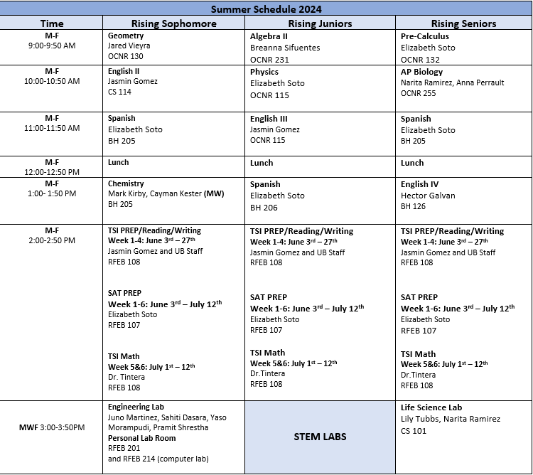

Transportation Weeks (1-6)
To/From
Transportation will be provided for students on Monday through Friday (Weeks 1-6) by your high schools.
Authorization for Pick-up
Cell phones and other electronics will be picked up at the beginning of each class, unless authorized by the class facilitator. Upward Bound students are the responsibility of Upward Bound staff during Upward Bound programming hours. When our programming is over, the parent(s)/guardian(s) must ensure their child is picked up and returned home from the high school pickup point.

Use of Cell Phones during Class/Activities
Students are not allowed to use their cell phones while in class unless authorized by the instructor or staff. Students may carry cell phones with them; however, during class, phones will be placed in silent mode or off, and placed in the phone holders at the front of each class at the beginning of class and will be picked up after each class. If a student’s cell phone rings during any activity, the phone will be confiscated by UB staff and will be returned to the student at that day’s floor meeting. Repeated violation of this rule will result in a student's dismissal from the Summer Academy. If parent(s)/guardian(s) need to get in touch with students, the student will be able to call a parent(s)/guardian(s) back between classes or activities.

Write-Ups/Violations
When every attempt has been made with a student to correct a behavior, and that student has chosen to continue to break the rules, the student will be written up. If the violation is a serious violation, a student can be written up after the first occurrence.

