What is Grammarly Authorship?

Overview:

Grammarly Authorship is designed to foster more transparency between students and faculty in the writing process. Grammarly believes that institutional awareness and support will be critical in ensuring Authorship is used as a valuable instructional tool. This FAQ document is intended to help administrators and faculty understand how Authorship works and to address initial questions that students and faculty may have before using the feature.

FAQs:
- Students have the option to click the “Track writing activity” button to turn on Authorship tracking for that single document session, or can take no action, in which case nothing is tracked.
- Students can select the "Turn on automatic tracking" option by selecting the settings cog in the upper right of the Authorship widget menu to have tracking start automatically when a new Google Doc is opened. This makes it easy to generate reports categorizing text sources.
- If users only enable tracking for the current document, they will need to turn it on individually from the "thumbprint" icon at the bottom-left of the document each time.

Pro Tip: Always check that tracking is enabled before you start writing to capture your complete writing process.

How does Grammarly know where the text comes from?

To use Grammarly's Authorship feature, it needs access to your clipboard to differentiate between different sources of text.

This access helps Grammarly differentiate between text from general AI sources like ChatGPT or Claude and text from traditional online sources like Wikipedia.

Without clipboard access, it can still document typing actions and actions taken within the document, but won't be able to attribute pasted text in more detail beyond "copied from an unknown source.

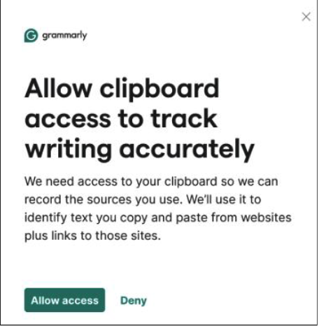

How do students know that Grammarly Authorship is recording activity in a document?

Students are always in control of whether Grammarly Authorship records their writing activity. When activity is being tracked, students will see a “Stop tracking” button that allows them to stop tracking.

How do students view their Authorship report?

When a student is ready to view their report, they can click the thumbprint icon at the bottom-left of their screen and click “see report.”

There are three different sets of information available: Authorship Analytics shows a breakdown of text sources, organized by “human-typed” and “sourced” categories, along with data about the amount of time spent on the document and the number of active writing sessions.

The Authorship Report includes the full body of text, color-coded by text category, along with details about the text source.

Authorship Replay shows full typing and editing history from start to finish. The replay is meant to help the student remember primary actions as the document came to life.

At the top of the report, there is a green “Share” button. Students will see a unique URL they can copy and share with faculty members. Faculty will only be able to see all of the same information the student sees in the report.

What content is attributed?
- Any text from a browser-based source where Grammarly is available will be attributed.
- Text from a generative AI tool, academic article, periodical, and more all qualify.

What happens if a student pastes content from an application that Grammarly Authorship can’t access?
- If a student pastes content into their Google Doc from a desktop source or an incognito window, Grammarly will categorize that text as “copied from an unknown source.”

What data does Grammarly Authorship collect on students?
- To provide a record of editing history, Grammarly Authorship collects the text written in the context of a document and pasted from Websites like Wikipedia and ChatGPT, as well as prompts used to generate output from ChatGPT or Grammarly.
- Grammarly does not collect or store any data that is not pertinent to the writing process.
- The student will not be tracked on browsing history or web traffic unrelated to text input via the clipboard.

Where is Grammarly Authorship data stored?
- While writing, Grammarly Authorship stores data on the student’s device and encrypts it using GCM encryption algorithm.
- Clicking “See report” sends the document data to Grammarly servers for processing, where it remains for up to 24 hours.
- Sharing a report sends the data to Grammarly servers and stores it for 12 months.

What Authorship data is shared with generating and sending a report link?
- When sharing a report, the reader can see all the same information as the author, including top-level document analytics, the full text color-coded by source, text insight cards, and a full replay of the typing and editing process.
- The replay feature includes the ability to see text being written and deleted, the names of websites where text is copied from, and prompts to generative AI such as ChatGPT.
- Students can preview the data available to their instructor by choosing "See report" and replaying the writing activity.
- They can also exclude the replay in the report when sharing, if they don't want their audience to see their entire writing and editing process.
Important Note: Submitting a Google Doc link requires the document to be shared with "anyone with the link."

Need Help? Contact Grammarly Support or visit the Authorship Support page

