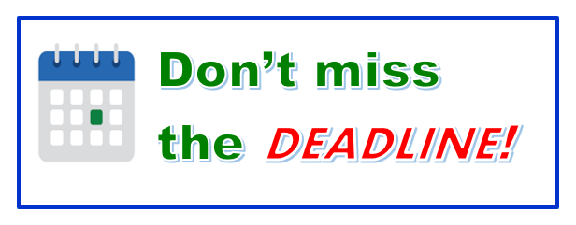
‌Dear [Student],
Professor [Professor] has raised a [Flag Name] alert for you in [Course Name]. If your professor has provided additional comments regarding this alert, those notes will be provided below.

Professor Comments:

[Professor Comments]

A message from the Office of Student Success:

We understand that managing and balancing life can be challenging. We encourage students to review the course syllabus regarding missing/late work and address faculty concerns in a timely manner. If factors outside of your control have contributed to missing/late assignment submissions, please communicate with your professor to keep them informed of your circumstances if you have yet to do so.

Please reply to this message if you have questions for your professor regarding the alert.

Sincerely,

Starfish
Office of Student Success
Texas A&M University-Corpus Christi
6300 Ocean Dr. | Corpus Christi, TX 78412
361.825.5700 | tamucc.edu

